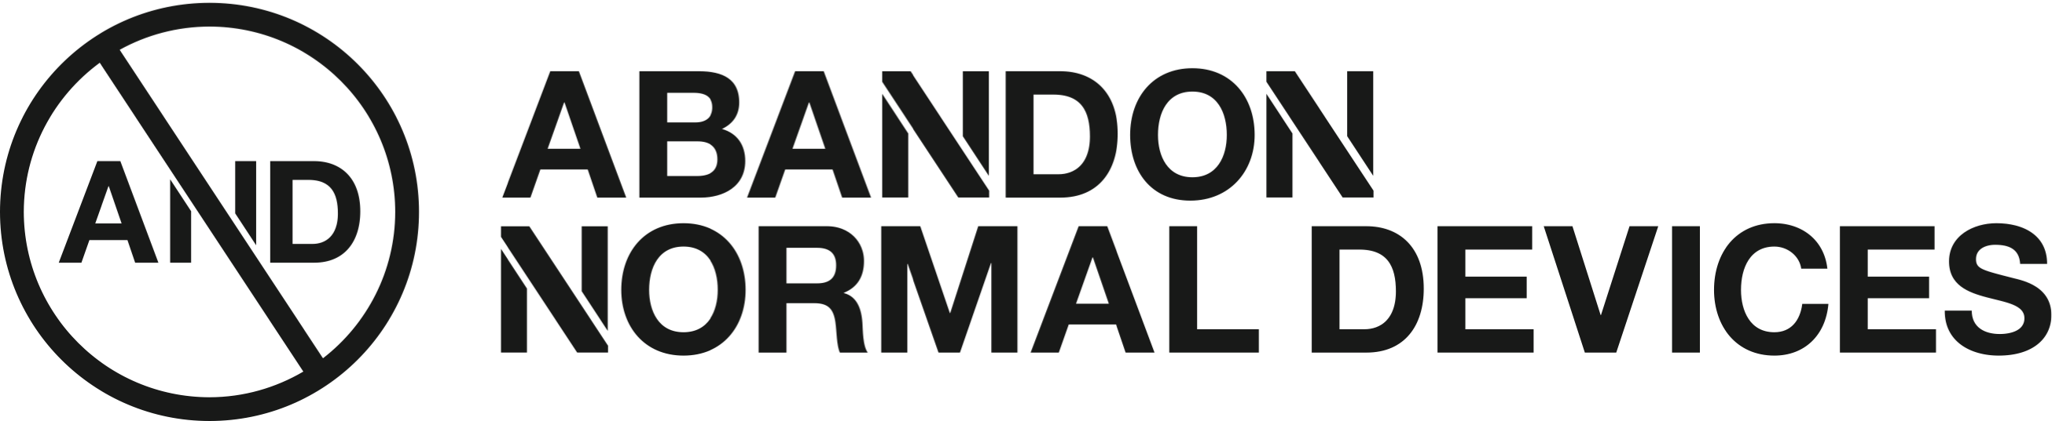

CALL FOR FESTIVAL FREELANCERS /
EVENT PRODUCERS & TECHNICAL ROLES
AND FESTIVAL, 21 – 24 SEPTEMBER 2017
CASTLETON, PEAK DISTRICT

DEADLINE: Rolling until 17:00 Monday 7th August 2017
AND is seeking to establish a team of highly skilled specialists to support on the delivery and install of the festival in Castleton during August and September 2017.
We’re looking for individuals with proven experience in the following areas to support on a programme of exhibition, events, interactive and outdoor installation and outdoor film:
- Event Production
- Technicians / with experience of artwork build and installations involving technology
- A/V install for film and live events
There will be roles throughout August and September, with a specific focus from the Mon 4 – Mon 25 Sept. You will be need to have experience working in an outdoors arts or festival environment.
ABOUT AND
AND is a commissioning agency, which produces cross platform projects including exhibitions, talks, interactive projects, film happenings and a biennial festival of new cinema, digital culture and art. We are a catalyst for new approaches to art-making and digital invention and invite artists to hijack the imagination through abandoning traditional settings and developing unorthodox partnerships so we can actively redefine the way that digital art projects, events and festivals are experienced.
Founded in 2009 by FACT, Cornerhouse and folly over the past 6 years we have commissioned over 80 artists including Rafael Rozendaal, Julien Oliver, Eva and Franco Mattes, Brody Condon, Andrew Kötting, Apichatpong Weerasethakul, Carolee Schneeman, Krzysztof Wodiczko, Gillian Wearing, The Yes Men and Jamie King. www.abandonnormaldevices.org
AND FESTIVAL 2017
This year AND Festival will be taking place in Castleton, Peak District National Park from the 21 – 24 September.
AND will enter the voids, shafts and veins of the peaks for a subterranean festival with 4 days of site specific installations, world premieres and performances. The programme will reveal the earth’s layers, from the drone’s eye view to subterranean bunkers – it will be a prophetic, provocative and uncanny reflection on the verticality of the earth. Going on a journey from inner and outer spaces, the festival will become a site for the symbolic and sub-conscious, a composing of artistic practices which invite us to reflect on groundlessness and deep time, artists will become archaeologists of the future unearthing rare sounds, simulated environments and technological ruins.
HOW TO APPLY:
Please submit your:
- CV (no more than 2 pages and including at least two referees)
- Short supporting statement (300 words max) highlighting how your specific experience relating to the role, any links to online examples of your previous work relevant to this role, daily rates and availability during August & September 2017.
Guidance Notes for Applicants:
- Closing date for applications is 17:00 Monday 7 August 2017
- Please insert APPLICATION FESTIVAL FREELANCER as the subject.
- We will review applications on rolling weekly basis and contact appropriate candidates to discuss the opportunity.
- To submit your application or for any queries please contact jobs@andfestival.org.uk

