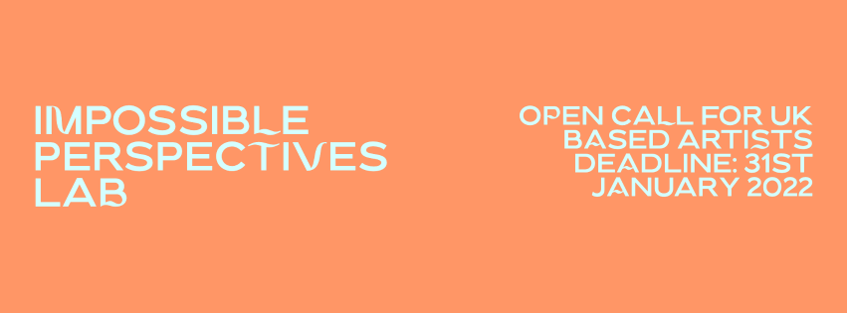

\\ ADDITIONAL INFORMATION

About Abandon Normal Devices (AND)
Abandon Normal Devices (AND) is a commissioning agency and a catalyst for new approaches to art-making and digital invention. We create ground breaking projects which challenge the definitions of art and moving image with a distinct emphasis on creative enquiry and provocations. Since its inception in 2009, AND has shaken the creative sector through radical, risk-taking projects that challenge conventional modes of participation, and stimulate new art forms and creative inquiry.

AND brings together an eclectic mix of academics, filmmakers, scientists and anarchists to actively push the boundaries of audience experience and arts production. Inviting artists to hijack the imagination, by developing projects which abandon traditional settings and partnerships.

Proposing a significant shift in the way art is experienced, the AND portfolio consists of site-specific film happenings, exhibitions, performances, online projects, residencies, public realm interventions and a roaming biennial festival. Audiences are invited to interact with bold ideas, encounter new art-forms and experience art, in the everyday and in unexpected locations.
About Tatton Park
Tatton Park is one of the North West’s most popular heritage attractions and one of Cheshire’s most valuable cultural, environmental and economic rural assets open to the public. It attracts 780,000 regional, national and international visitors annually, contributing £34m gross to the regional economy.

Tatton’s visitor attractions include 1,000 acres of Grade 2 Parkland and Gardens, a neo-classical Grade 1 Mansion, medieval Old Hall, heritage farm, shopping and dining options, children's play areas, holiday accommodation, cycling, horse riding, fishing and sailing. Tatton also provides facilities for filming, meetings, functions and celebrations and hosts over 100 events annually, comprising award-winning education activities for over 24,000 children, music, motor, food, outdoor cinema shows and the annual RHS Flower show.

About Cheshire East Council (SHIFT)
Cheshire East is at the heart of the North’s creative cluster, with around 2,000 businesses employing just under 5,000 people. Nationally, the Creative & Digital sector has grown 30% faster than the rest of the economy in recent years. While the majority of the sector’s businesses are small to medium enterprises, Cheshire East is also the home to many multinational corporations including McCann, Barclays Global Technology Centre and Chillingo (Electronic Arts) mobile game publisher of hit iPhone titles Angry Birds and Cut the Rope.

With significant investment from Arts Council England and Cheshire East Council, SHIFT has created a borough-wide celebration of its ongoing digital output and a delivered innovation, interaction, inspiration and immersion in the digital and new media potential across the region. Its key aim is to make participation in the digital world accessible for all – through its hands on events staged in a variety of surprising and unusual spaces across the region. to experience art in everyday and unexpected locations.

About Canaletto
Giovanni Antonio Canal, known as Canaletto, was born in Venice, the son of a theatrical scene painter. He was very influential, famed for his precisely depicted and evocative views of the city. In 1746 Canaletto departed Venice for England where he worked for the next decade. His work placed an emphasis on satisfying composition above actuality of representation - therefore creating impossible perspectives, and imaginary views of cityscapes known as capriccio (architectural imaginaries).

Equality & Diversity
Abandon Normal Devices is committed to equality of opportunity for all. AND champions an open, critical creative culture, with the mission to challenge what is normal in our society through programmes that include cultural activism, global perspectives and underrepresented voices. We want to reflect the diversity of our audiences in our programme; therefore, we actively seek and welcome applicants, including but not limited to; those from ethnically or culturally diverse backgrounds, diverse sexualities and genders, disabled and d/Deaf people, or those with unconventional career paths.

All of our collaborators are asked to respect and value this commitment, and AND’s Code of Conduct.

As partners we recognise the difficult origins of historic estates in the UK and beyond. Tatton Park was included in the National Trust’s review and recent report on 'Addressing our histories of colonialism and historic slavery’. Although no issues were highlighted at Tatton Park as part of this review, through our work we understand and accept the need to question representation of wealth and power in support of social justice and equity.
Environment & Sustainability
AND declares a Climate and Ecological Emergency and is making efforts as an organisation and as individuals to achieve Net Zero by 2025. We are actively working to imagine and model ways that we can encourage sustainable practices internally as well as with the creatives and individuals we work with nationally and internationally. As a National Portfolio Organisation funded by Arts Council England, we report on our environmental activity through tools and resources provided by Julie's Bicycle, including the development of an environmental policy and action plan. We support and encourage our staff, artists, partners, volunteers and everyone we work with towards creating a green, sustainable future.

